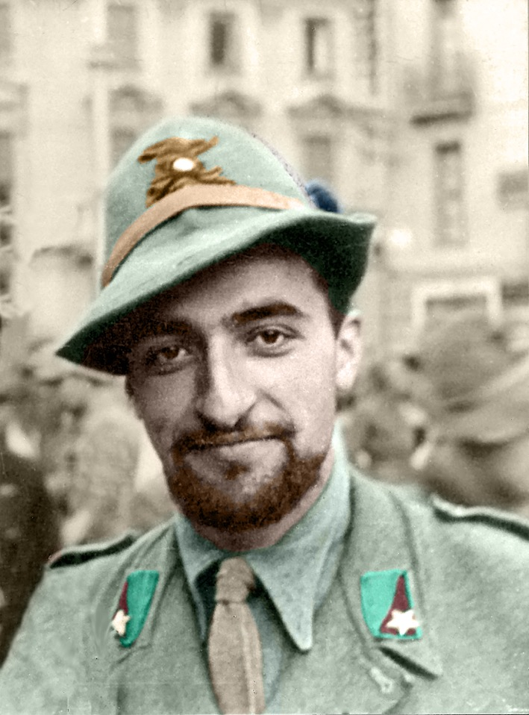

*Blessed*

Teresio Olivelli

BIOGRAPHY

Blessed Teresio Olivelli was born on 7 January 1916 in Bellagio (CO) and in 1926 moved with his family to Mortara (PV). In 1938 he graduated in law at Pavia. He actively participated in Catholic Action, then in FUCI and in Saint Vincent’s. In 1938 he was an assistant at the University of Turin and began moving toward Fascism since he maintained it had aspects compatible with Christianity. He sought to enhance these elements by seeking a Christianization of Fascism, though he subsequently realized this was impossible. When Italy entered the war he left for Russia as a sub-lieutenant in the Alpini in order to share the fate of those who were forced to go to the front. He prayed with and comforted the weak and fearful, bringing Christ to those trenches of death. In the tragic retreat he helped the injured while all were fleeing.

Returning to Italy, he refused to stand alongside the Nazi anti-Christian ideology and was sent to prison camps. He fled and joined the Catholic resistance, assuming a formative role, and spread its moral values. He fought with ideas and gestures of solidarity; his weapons were love of neighbour and self-sacrifice. He founded *The Rebel* newspaper, and wrote the *Signore facci liberi* prayer, known as the “rebels’ prayer for love”.

He was persecuted by the Nazis because he rejected hate and spread the values of Christian humanism. He was arrested and deported to the camps of Fossoli, Bolzano, Flossenbürg and Hersbruck, where he engaged in religious and charitable activities, praying with and consoling the weakest and the sick, offering them spiritual help, and giving away his small ration of food. The Nazis beat him continually because they hated his faith and Christian witness, but he never grumbled and gave them his forgiveness. On 31 December 1945 he embarked upon a radical gesture of love: he used his body as a human shield to protect a young man who was being brutally beaten by a guard, and was badly wounded in his stomach. He was taken to Hersbruck's infirmary but died on 17 January 1945.

PRAYER

God, our Father, we thank you for having given to your Church the heroic witness of Blessed Teresio Olivelli, who everywhere spread the light of faith, the enthusiasm of hope and the fire of charity.

In imitation of Jesus, the good Samaritan, he came to the aid of the poorest, the weakest and the most helpless, offering his entire self even to the supreme gift of his life.

We pray that, imitating your martyr of faith and apostle of mercy, we may follow your only begotten Son in building a world of justice and peace.

Through the merits and prayers of Blessed Teresio Olivelli, we confidently ask you to grant us this grace. We praise you, Father, through Jesus your son, in the power of the Holy Spirit, for ever and ever. Amen.

*____________________________*

*To whom he thanked the intercession of Blessed Teresio Olivelli, he is kindly asked to report: Mons. Paolo Rizzi, Postulator Cause of Canonization Blessed Teresio Olivelli, Piazza S. Ambrogio, 14-27029 Vigevano (Italy);* [*postulazione.olivelli@virgilio.it*](mailto:postulazione.olivelli@virgilio.it)

website: www.teresioolivelli.com